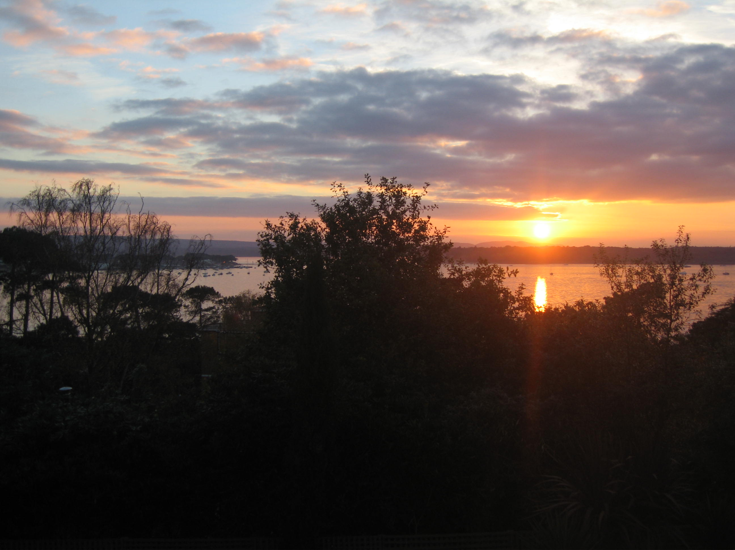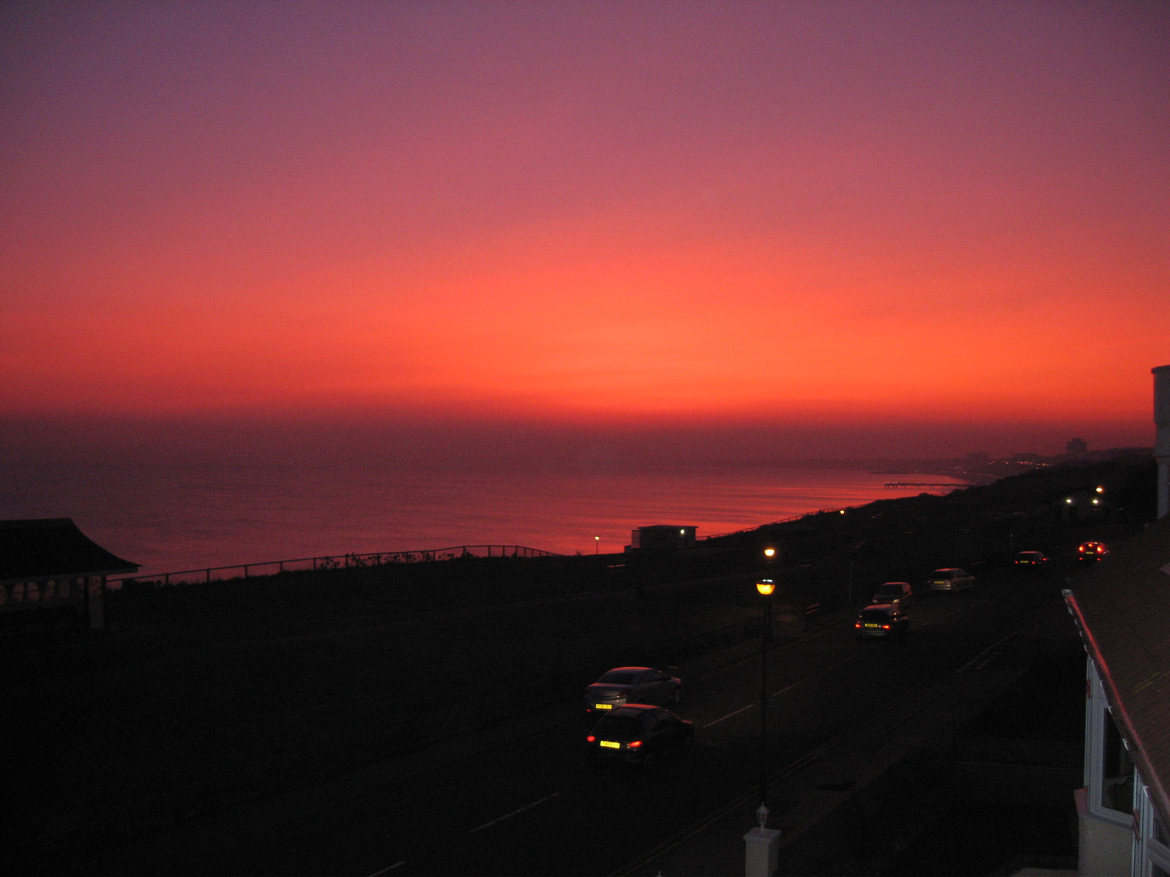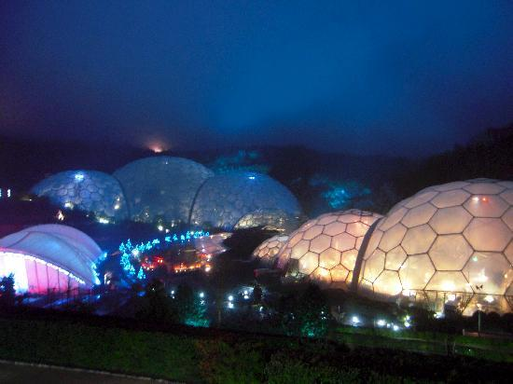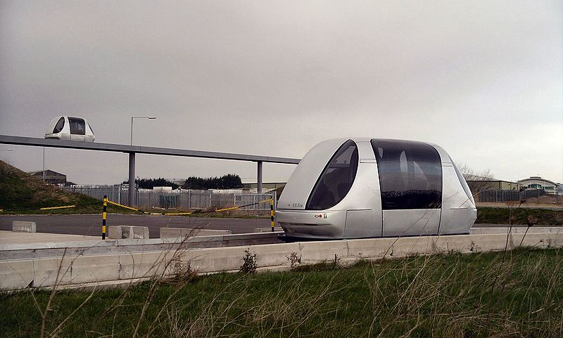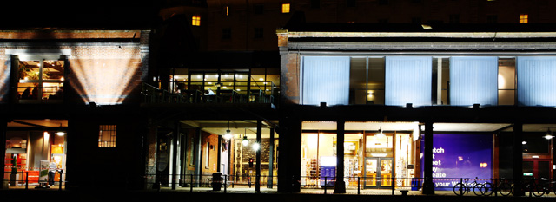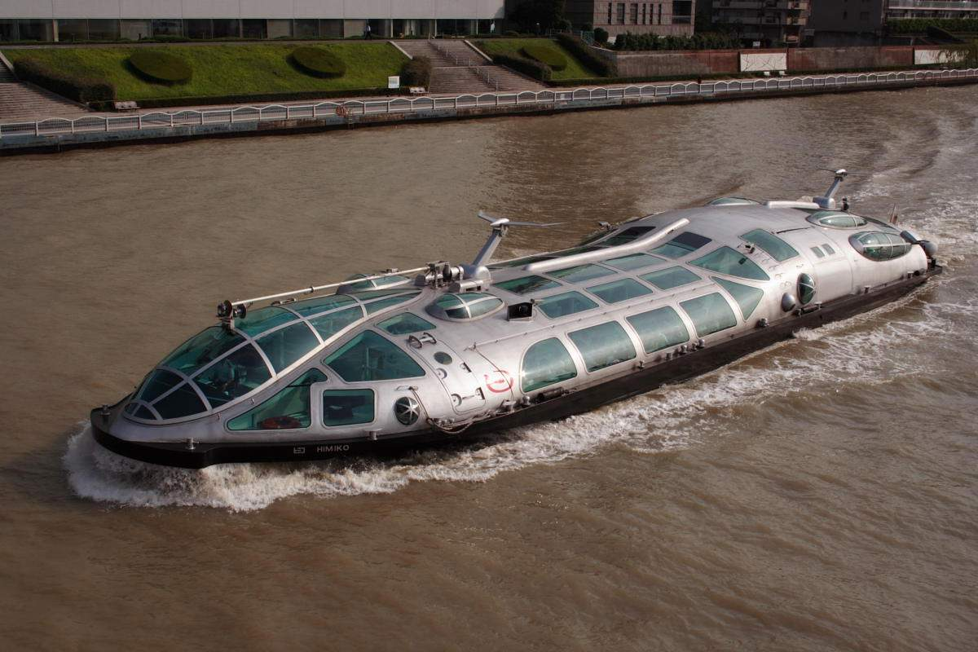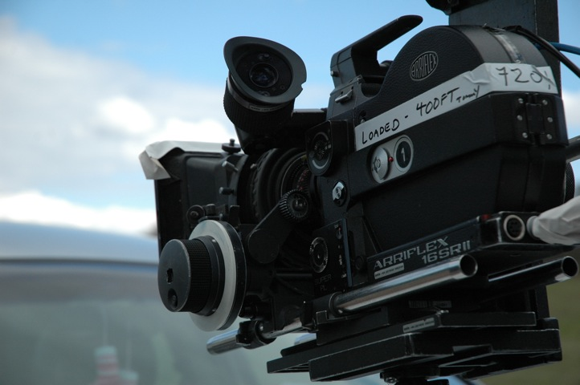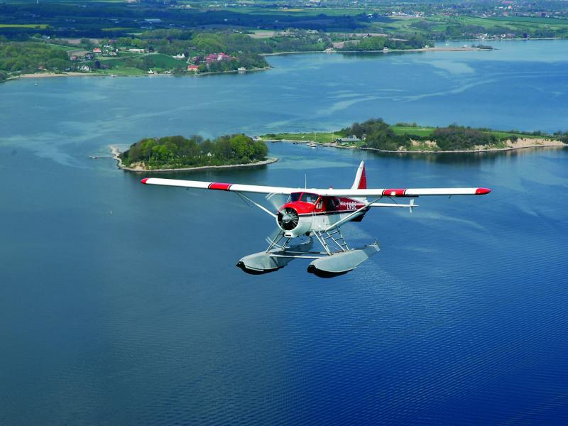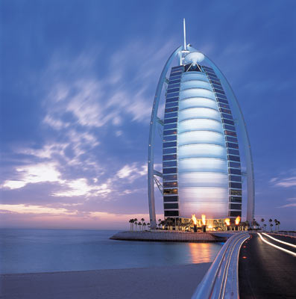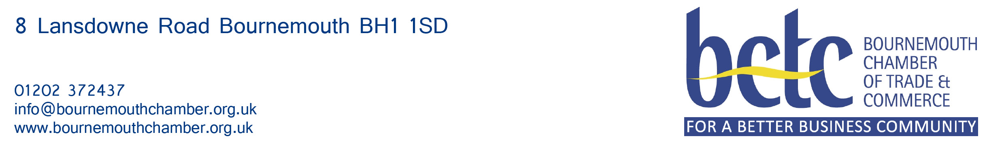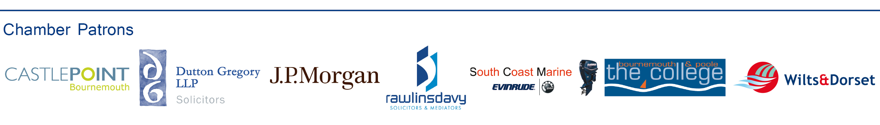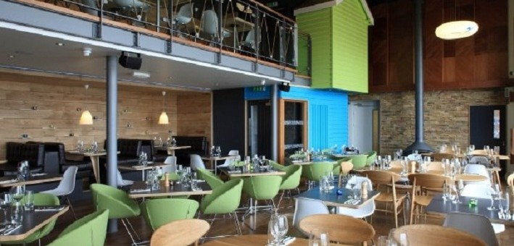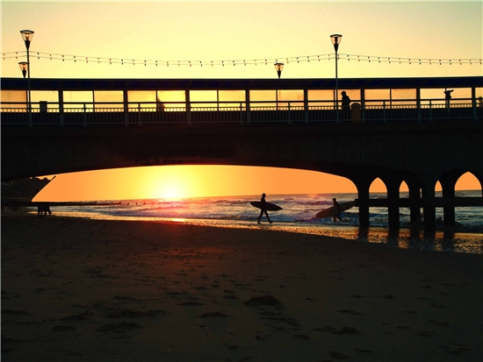

Initial ideas presented

at

The Greenhouse Hotel

Bournemouth

14th January 2011

Contents

# 3. Table of Contents

# 4. Strengths and weaknesses of Bournemouth

# 5. Introduction

# 7. Bomo City

# 8. Sub-tropical Leisure Complex

# 11. Improving the Connectedness of the Conurbation

# 12. BoMoBiz

# 14. Bournemouth Creative Centre and Architectural Masterpiece

# 15. Wi Prom

# 17. Dedicated Spaces

# 18. Conurbation Waterbus

# 19. Intelligent Fitness Club

# 21. Bournemouth Festival of Film

# 22. Looking into the 21th century – A monorail

# 23. Simple Arts Collective

# 24. Air Service – from the sea

# 25. Arts Centre

# 26. International Arts Centre

# 27. Worthy and Iconic Landmark Building for Bournemouth

# 29. Bournemouth Chamber of Trade and Commerce

# 30. Future Dates

Strengths and weaknesses of Bournemouth

(not exhaustive)

Introduction

AFTER the General Election in 2010 a group of Bournemouth-based business people got together with Tobias Ellwood Member of Parliament for the Bournemouth East Constituency, to discuss how they could create a forum to share ideas and promote discussion about the future of the Bournemouth, Poole and Christchurch conurbation.

We wanted to give more people a chance to make a contribution to the local community on the basis of their skills, their lifestyle and their needs.

The purpose of the Conurbation 2050 group is to bring together entrepreneurial and public-spirited individuals, so they can share ideas and do things together, using their own initiative.

The economic climate means that we can no longer rely on public grants so we aim to raise our own money and complete modest projects. Of course if grants are available we will attempt to access them.

The really important thing is anybody can come along to one of our breakfasts or lunches, and share an idea, however unconventional or impractical, and get a hearing in front of influential members of the community.

Spectacular sunset over Bournemouth Bay

We need to implement the unification of the Bournemouth, Poole and Christchurch local authorities at the earliest opportunity. The new authority will be called BoMoCity. There are three reasons why this political change will be necessary.

1) Poole, Bournemouth and Christchurch cannot fulfill their potential as separate places. We already have the anomaly of Bournemouth airport being in Christchurch, and Bournemouth University campus being in Poole. The M2 bus runs from Poole to Christchurch, and it feels like one place. The coastline from Hengistbury Head to Sandbanks links one urban sprawl. BoMoCity’s time has come. The new name will give the place coherence.

2) This is the way the sea wind is blowing. The public sector will never be the same again. Economies of scale mean that we need one tourism policy, one arts policy, one cleansing contract and one social services department for the whole of the conurbation. Our most important industry is tourism. Instead of promoting Bournemouth, Poole and Christchurch we can say, “Come to BoMoCity”.

We will pay councillors more. They will now be administering a city not a town, but we won’t have 123 of them, we’ll probably have half that many.

3) Los Angeles was a settlement founded in 1781 a group of ex-slaves. That's only 30 years before Lewis Tregonwell settled in Bournemouth and started planting the town's distinctive pine trees.

The population of the city of Los Angeles grew from 175,000 people to 1,750,000 between the years of 1900 to 1925. We need to stimulate a similar growth in population.

The conurbation has a population of 383,713 - that's bigger than Cardiff at 324,800, but it will have to rise exponentially. The conurbation offers the best climate, the best landscape and the best lifestyle in England. In the footloose world of modern mobile communications, people will gravitate towards the places that have the best quality of life. This is BoMoCity’s opportunity.

If the country is to generate wealth to maintain its future position in the world, BoMoCity has to be the British, Palo Alto, the centre of technological innovation which powers our economy.

Go west, the American pioneers said. That’s what Londoners will be repeating in the C21st as the civic leaders of BoMoCity set out to build the world’s most advanced metropolitan community on the edge of the South Coast.

**The vision for BoMoCity**

**Brian Jenner**

**A unique glass covered sub-tropical leisure complex linking the cliff-top to the sea in Bournemouth**

**Sarah Uzzell**

The Eden Project on a rainy day by G T Alli

Using the height of the cliff and the width of the beach to create an amazing space that enables visitors to enjoy the best of Bournemouth all the time. It will be a sensory delight with natural light coming through the glass bubble visitors will be able to enjoy the stunning views of Bournemouth bay, benefit from the healing properties of the sea water and the sound of water as well as the tropical atmosphere created with clever heating and ventilation, tropical planting and wildlife as well as natural stone and other materials. This will be an environment that is fun for families as well as relaxing and calm for adults and available 365 days a year.  The complex will be accessible and welcoming to all.

The sea will be the unique factor - the water attractions will be based on sea water in a tropical heated environment. There will be river rides, waterslides and a pool as well as mini rock pools and slides for younger families. There will be quiet relaxation and spa areas inside as well as plunge pools and hot tubs outdoors and the 'real' beach facilities for relaxation.  The water rides and the beach will be inside and outside the subtropical bubble (and will continue whatever the weather).  The beach and the sea itself can offer an educational dimension.

There will be dining, cafe, retail and spa treatment facilities.  It will be an attractive place to go any day of the year and will cater for visitors coming in from the weather outside. The atmosphere all year round will be tropical - so visitors will wear swimming costumes or light clothing inside and take beach towels. There will be lockers and storage for outdoor coats, buggies etc. as well as showers. There will be plenty of seating throughout the complex (spread among the tropical plants and natural stone, at different levels thoughout the complex benefiting from incredible views throughout the height of the structure). Seating will not be in vast open spaces like a leisure centre swimming pool.  The lighting will be part of the atmosphere and the 'theatre' of the sub-tropical environment (enhanced by the natural light (or dark at night) through the glass bubble roof.

This complex will be somewehere to spend 4 hours or more. Visitors will purchase a day pass.  Accommodation providers will be able to sell the pass or package it as part of marketing their services. Local residents may purchase season tickets for regular access.

**Where?**

**On the East cliff between Boscombe Pier and Bournemouth Pier from the cliff top down into the sea**

Accessible from the cliff top using a lift or escalator as well as from the promenade.  The glass bubble will enable visitors to maintain contact with the view of Bourneouth Bay throughout the complex.

The promenade along the seafront will be preserved allowing traffic (pedestrian and train) to continue to travel from pier to pier uninterupted.  The sub-tropical complex will be built around the promenade with a clear tunnel (or bridge) so that the complex can be viewed from inside to outside (and vice versa).

**My inspiration for this initiative:**

- The Eden Project: for its glass dome, sub-tropical atmosphere and green credentials

- Centreparcs Sub-tropical paradise: for its success as a leisure complex for all ages, open 365 days a year, combining the family and adult market (spa and relaxation facilities) and its success at linking the indoors with the outdoors

- Atlantis The Palm in Dubai - for its audacious ambition, scale and presence

- Disney: for the professional, slick delivery to create a theme that works 365 days a year in all weathers as well as clever engineering to support the magic and the theatre

Pod Cars

Big improvements could be made to the ways in which people move around the Bournemouth area with a system of driverless pods similar to those being introduced at Heathrow Terminal 5.

Attractions and places of interest in the conurbation are quite widely distributed. Getting around in practice involves road travel, either by bus or by car, which will lead to greater congestion and put increasing pressure on the road system and central parking facilities. Those who do arrive in Bournemouth by public transport (coach or rail) find themselves over a mile from the town centre and beaches and have to undertake a further bus journey. This proposal would make the final leg of the journey into an experience in itself.

The system is based on fuel efficient, driverless pods which follow a defined route either based at street level or on an elevated track. Pods are picked up at various stations by individuals travelling together or by family groups and run to defined destinations which could be selected by the passengers. The main connection would be from the travel interchange to the town centre/Lower Gardens (down the Old Christchurch Road) and up to the Triangle. Optionally the route could include a loop back to the Interchange via the Gardens and the Overcliff drive on the east cliff. Extensions to the route could take passengers from Kings Park (linking to the football ground and proposed ice stadium perhaps) or to Westbourne.

Combined with the new transport route would be a Park and Ride scheme. There is a lot of scope to extend parking facilities around the existing travel interchange using the Asda site, the Cotlands road car park, the former B&Q site or undeveloped land adjacent to the St. Pauls Road/Wessex Way roundabout. Visitors will always want to come to Bournemouth by car but this proposal would aim to keep cars out of the town centre by putting the emphasis on an iconic “Ride” in the Park and Ride scheme.

**Improving the Connectedness of the Conurbation**

**Bernard Uzzell**

BoMoBiz

Nicholas Steven

It’s 2025. Tobias Elwood is Prime Minister and Brian Jenner is Mayor of BoMoCity - the largest and most prosperous non-industrial conurbation in Europe.

Deep within the breast of this political and economic miracle beat the left and right ventricles of the profit generating heart that has bankrolled this extraordinary development. Fifteen years earlier, WSX Enterprise, an unremarkable government-funded social enterprise trading under the Business Link brand, was providing a mix of light-touch, low-cost support to small businesses and a sprinkling of higher-value services to medium-sized companies. It was seek, stable and secure - until its funding stopped.

Based on advice from a group of entrepreneurs meeting for lunch at the The Green House Hotel on 14th January 2011, WSX then took a daring decision.

It was offered two attractive but conflicting development strategies. One strategy was for WSX to become an out and out commercial operation, red in tooth and claw, offering high-value business support services to medium-sized companies. The other was for WSX to turn itself into a community interest company and, seeking funding from a wide variety of donors, continue to run programmes for those micro businesses and start-ups, which had no other means of support.

Focus is the key to business success.

To the surprise of many, WSX Enterprise next fearlessly allowed itself to be composted, so that two vigorous new shoots might grow out of its rich mulch. The first, BoMoBiz Plc, took on the target of trebling the value of as many medium-sized businesses in the conurbation as possible. It worked with many local growth-ready businesses, enabling them to generate more sales and profits. Over the next 15 years, incubator units were built, venture capital funds launched, business conferences hosted, bigger businesses imported from London, banks embarrassed into lending and economic development departments taken over. The result was that huge critical mass reaction, which fills BoMoCity’s coffers today.

The second new shoot was BoMoBusinessCoop. This not-for-loss community interest company, set to work championing and supplying the support needs of smaller businesses and start-ups, raising, distributing and recycling over £300m of cash, expertise, business premises, labour, equipment and other resources over the next 15 years. Recent graduates were found gainful employment, retired business experts were recalled to advise, micro credits distributed, dole queues slashed, business cooperatives created, best practice promoted, funding plans written, capital raised, donations received, unnecessary bankruptcies extinguished and start-up success rates increased 100 fold.

*'We shape our buildings; thereafter they shape us.'*

What the town needs is an award winning, international landmark and community space that the people of Bournemouth can be proud of. An iconic building that allows the natural beauty of the Purbecks to be framed and enjoyed, where art and culture are accessible to all and where residents, tourists and creatives can rub shoulders enjoying local and international talent.

The Winter Gardens are but a distant memory, the future of the Imax is open to the imagination of us all. The possibilities for a shining piece of architecture, a future jewel in our crown that will add to and compliment the Russell-Cotes Museum is within our grasp.

We already have an international award-winning architect/designer standing by to turn this into a reality. He has been sent the initial plans and public ideas for The Waterfront and has expressed a genuine interest. So you see, the Imax is already attracting to Bournemouth the most creative of talents!

Poole has its Lighthouse, Bristol its Watershed, I imagine a 'Festival Hall by the sea' for Bournemouth. Somewhere to meet friends in all climes, take in an exhibition, a foreign or art house film. Eat, chat, access the internet, watch the sunset, create new ideas in wonderful exciting spaces, using the latest technology in the most ergonomic and eco-friendly environment. A place where comedy and creativity can thrive and where our future graduates and homegrown talent have a platform to shine.

We need a venue where all the creative groups are concentrated into one united hub. At the moment the town has so much to be proud of already, with its award winning blue, green and purple flags of excellence, let's wave them all in triumph above the finishing touch of an inspiring, award-winning magnet for culture. Winston Churchill expressed it perfectly, *'We shape our buildings; thereafter they shape us.'*

**Bournemouth Creative Centre**

**and Architectural Masterpiece**

**Johanna Lawrence**

**Wi Prom**

**Monica Seeley**

**Dorset Chamber of Commerce’s Digital Taskforce**

Regardless of whether it’s good for our work-life balance there is no escaping the 24x7x365 business culture, especially if you want to be a global player. But what if you are on the beach either sun bathing or just cycling and need to access the internet. Not too difficult with a 3G phone although it might be slow.

What if the entire seven mile promenade from Hengistbury Head to Sandbanks were to have wireless access to enable anyone to do business anywhere, whether laying on the beach or sitting in a café, and whether they had a mobile device or not?

By 2050 the whole promenade should have superfast wireless internet access with cyber pods every half a mile. This would add to the image of Bournemouth as the place of choice for the discerning business man/entrepreneur. It would also give us an advantage over Brighton (our main costal rival for the discerning entrepreneur wanting great business facilities combined with extraordinary leisure facilities).

Monica Seeley, Chairman of the Dorset Chamber of Commerce’s Digital Dorset Taskforce

Contact information: tel 01202 434340: email [monica@mesmo.co.uk](mailto:monica@mesmo.co.uk)

“Innovate, Co-Create, Celebrate.”

**“Dedicated Space”**

Laura Capellaro Cousins

I'd like to tell you about a vision of a dedicated space where people can come together to create art, words and music as an exercise in community or team building, with the aim of fostering a greater degree of empathy and understanding between groups, with the ultimate goal of working towards cooperation and integration.

Group artistic activity is a proven way to demonstrate metaphors of cooperative practice and to allow people to discover new ways of solving problems. The education system in this country has failed to place any emphasis on the arts for several decades now and as such we are seeing a whole generation of people who consider themselves incapable of artistic expression or innovation, at a time in our country's history when a more creative approach to the problems we all face every day would be most beneficial.

I come to this idea as someone who has run workshops in storytelling, music-making, drum circles and song writing. I'd love the Conurbation to be known as a part of the country that celebrates and fosters the growth of artistic collaboration between disparate people of all assumed levels of ability. I'd like to seek out and develop a suitable space - or spaces - fully equipped, accessible to all and permanently staffed, where people can converge and create together even if only for the sake of taking part. My motto, borrowed from a friend in London, is “Innovate, Co-Create, Celebrate.” I want the Conurbation to be known all over Europe and the rest of the world as a place that pioneers this approach in full partnership with local businesses, media, political and community organisations, providing a role model for people to re-engage the creative sides of themselves for the greater good.

©Laura Capellaro Cousins 2011

Bournemouth and Poole are like conjoined twins, having very different personalities but eternally connected, whether they like it or not. Two assets that they share are a seafront location and an economy in which tourism plays an important role. What better way to link the two towns that via a scheduled waterbus in the Summer from Poole Quay to Bournemouth Pier. Not only would this serve tourists, taking them from one tourist centre to another, it would be available for people to travel to work, giving local people more opportunity to experience our wonderful maritime location and making that commute a little bit special.

“Himiko” A Tokyo Waterbus

Summer Conurbation Waterbus

Mark Howells

My name is Leysan Shafikova. Originally I’m from Russia and I’ve been studying a Masters in International Business and Finance at Bournemouth University. I have also worked as a swimming pool attendant in the Britannia Hotel to pay the bills.

I’ve realized that in Bournemouth a lot of people would like to do something apart from their studies or jobs. They would like to develop their ideas and skills; they want a place where they could do that.

In other cases people just don’t know what to do with their spare time – that is the reason why they waste it on Facebook, in front of TV or in the pubs. People in Bournemouth want to get together, communicate, share their same interests and have some support. That’s why they need a community where they could generate their ideas further and bring more to the town.  
  
And here is where **Financial Literacy Training** comes in.

My **Financial Literacy Training** would be a powerful support system, a community and a place to begin with - that is helps people to clarify their ideas and find support for their projects. This powerful community would provide financial literacy training and would be shaped by a programme I’ve studied through the International School of Investment and Finance (ISIF).

It is the place, where people can develop their eight main areas of Life around a familiarity with the way money works: Inner World, Health, Family, Career, Wealth, Environment, Life Style and Heritage.

It is a platform where they can **Hear, Share and Act**.

"**Hear**" by learning about the latest news, tips and strategies in business from other experts and world leaders and getting new skills. It provides by training sessions, workshops and an individual education program.

"**Share**" where they share their insights and experience and anything they feel inspired to share with the rest of community of Bournemouth. “Brainstorm” sessions will help people to come up with new ideas or to find a solution to problems.

And "**Act**" - because within this community each and every one of us has a chance to ACT:

Within this community people learn how to use their personal finances wisely, so they will become their own financial experts.

1. By getting involved in different events (sport events, different activities outside, cultural and other developing events) – we will give them an incentive to achieve their goals through the support of a friendly social network.

**My Financial Literacy Training** would educate people and give them hope. It will provide opportunities, so that anyone can contribute their bit to the community.

I believe that now is a new era of collaboration; when people are getting together, when each person can make a difference. And the people of Bournemouth can lead the way in this new era.

**Intelligent Fitness Club**

**Leysen Shafikova**

**The Bournemouth Festival of Film**

**Timo Peach**

**Rosie Jones, Howard Shepherd Tricia Walker, Mark Harris Johanna Lawrence and Steve Parselle**

Some 200 years ago, the town of Bournemouth was established as a place to come and rest, recuperate dream dreams and gain a fresh vision - maybe in part that vision has been lost. Bournemouth should once again become that place and inspire originality.

Our idea is about where to start.

The Bournemouth Festival of Film is to be an international film and fringe arts festival at the heart of the South Coast.

We want to put the town of Bournemouth on the map - internationally, creatively and in the minds of residents. Bournemouth is uniquely placed to offer something new and fresh - competing against Brighton, Manchester, Birmingham and London, in the UK but gaining the status of Barcelona, Buenos Aries, and Sydney. The festival could become a brand-defining event for council strategy.

Located within the very town centre, drawing together a number of iconic and landmark venues, the festival would transform central Bournemouth into a single creative identity. An easily accessible and manageable hub utilising Westover with its cinemas, The Pavilion, The Pier Theatre and the many hotels.

Crucial to the success of any arts festival in Bournemouth is that it works at both ends of the spectrum - from the creative individual to the biggest names in film and creativity. It must inspire big ideas to associate with it, and local creatives to want to feed it. The event itself would be the tip of the iceberg.

There are four key components to building a sustainable business plan for the Bournemouth Festival of Film. Each feeding the viability of the other:

1. A brand website - offering a consistent and comprehensive way to find creative events and talents locally.

2. A brand festival - a crucial expression of Bournemouth’s creative identity, a chance to shout about the town on the world stage, attract talent, business, finance. All adding to the branding of the town.

3. A brand educational programme - to nurture talent, create opportunities for creatives to meet each other to learn, train and share experiences.

4. A brand arts and film centre - a successful festival would, essentially, give us the business model for a permanent, year-round attraction and facility, right in the heart of Bournemouth - a centre for the arts.

We believe that such a festival can be done, in practical steps. Now is the perfect time to for those steps to be taken seriously.

Looking into the 21th Century – A monorail

David Trenchard

Transport for the public within the conurbation is currently limited to Bus, Car and Bicycle. There is a Rail link running East to West linking the Town Centres of Christchurch, Bournemouth and Poole and this is used mainly for people coming in from outside the conurbation itself. There is no link Northwards – to the South is the Sea.

All new developments in recent years have been restricted by the Road Network, the shortage and costs of providing on site car parking.

The Bournemouth Airport although recent has recently had a huge investment in new terminal buildings and updating facilities. It suffers from severe traffic congestion at certain times of the day and also suffers from lack of links to bus routes and rail network. Bus routes cannot be easily provided.

The New Royal Bournemouth Hospital was built on vacant land off Castle Lane and suffers from severe traffic congestion at certain times. There are bus route links but no link to the Rail Network. Car parking on site for staff, patients and visitors is severely restricted. The Law Courts are next door the same problems

There is a solution

A state of the art light train service or monorail designed in such a way as to be a Tourism Asset as well as providing a practical travel solution serving several locations and enabling better use of existing car parking facilities and enabling new parking near to key traffic routes.

The Chase Manhattan/JP Morgan Bank site is also very short of on site parking to the extent that a nuisance has been caused to neighbouring roads with staff seeking alternative parking. The Littledown Sports Centre, The AFC Football Ground, the planned Ice Skating Centre would also benefit from such a link.

If the decision is made fairly soon and the route set aside it could be routed over fields, common and Kings Park with very little impact on residential homes.

The final Station could be adjacent to the Kings Park Hospital Grounds and a covered walkway added to create a link to Pokesdown Station providing a very easy link between these points and the railway.

The Route is Bournemouth Airport Terminal/Car Park, across the fields south, over the A338 to run alongside the Treatment Works and Iford Golf Course, a Station by the Law Courts, then a Station serving the Hospital and nearby Offices, over Castle Lane to Littledown Centre, alongside Chaseside with a Station to serve JP Morgan, through Littledown Common to Kings Park with a Station adjacent to the Athletics Centre/Dean Court Football Ground to a terminal as near to Pokesdown Station as possible.

This should be a reasonably achievable objective solving many problems and contributing to the improvement of use of all the places served, improving on car parking income in Kings Park and at The Airport and cutting a certain amount of Traffic Congestion.

Now – about the funding................................ David Trenchard 2011 – Idea First floated 2006

The “Simple Arts Collective” is a new Creative Industries Social Enterprise for Bournemouth, Poole and Dorset and one of the few UK’s only creative and applied arts business incubators for designers-makers. We are, focused on nurturing and supporting talented designers and artisans with an applied arts basis to their work

Our Mission

We will support and promote talented designers-makers from all backgrounds through all stages of their career. We strive to raise standards in the contemporary craft, applied arts and design sectors, making an important contribution to the UK cultural landscape and economy.

We help all resident designers-makers to grow their businesses and many more through our dedicated programme of development workshops. We work with both new and established businesses aiming to increase profitability without compromising on creativity. Our bespoke incubator package aim to fast-track business success and includes managed studios, on-site one to one business development coaching, professional development workshops and events, gallery showcases, promotional and selling opportunities, resource centres and office facilities.

Unique solutions are created at our facility including: Art, fashion, jewellery, interiors products, specialist crafts, photography and more. We are able to organise high-profile events to showcase and promote the creativity of UK designers-makers. This includes our open studio showcase events, which offer the public an opportunity to see behind the scenes and buy direct from the designers.

Now you know what we can offer you, the next stage is to submit an application.

The offer of studio space in one of our incubators is by selection and there is a two stage process. Full details including selection criteria, services and charges can be found in the Application Pack.

The Simple Arts Collective is a social enterprise; therefore our fees are lower than commercial rates making the incubator package affordable. To give you an indication of price – the monthly charge for 100 ft2 including all of the services, water, heating and service charges is £250 per month. From time to time we are also able to offer sponsored Awards to applicants who are in greatest need of financial support. Information and updates about these will be published when they become available.

Simple Arts Collective

Grant David Read

A new air service offering scheduled, charter, business and pleasure flights based in the Bay.

If the weather turns nasty then Bournemouth Airport can be used until calmer waters return and transport provided between a terminal on the seafront with the airport.

This service is already up and running in Hamburg Germany. Bournemouth will be soon………

Air Service - from the sea

Jack Romero

“there is a wealth of creative talent here”

My vision for the future of Bournemouth would include a modern arts facility – a flexible modern gallery and workshop space with a café perhaps. I have always been astounded that Bournemouth doesn’t have this already. It could run as a complementary business to the Russell Cotes and the Pavilion as it offers a different thing. I would love to see exciting and international exhibitions and launches there, but also to showcase our wonderful local talent. There is so much scope for development in this area. Regular classes and workshops, for locals and visitors of all ages, run by local artists, which then keeps the money in our local economy.

One thing I have learned since moving to Bournemouth is that there is a wealth of creative talent here, and I keep finding new and amazing people all the time – we also have a talented student presence and one of my aims would be to integrate them into the town more, to give them a real sense of the place and hopefully encourage them to stay and set up business here when they graduate rather than disappearing off to London! We don’t make the best of our talent, and I see this as an opportunity that shouldn’t continue to be missed.

Elanor McBay, Founder of Bournemouth Creatives

Arts Centre

Elanor McBay

An International Arts Centre

Ruth Kelvin

My vision is for Bournemouth to become a centre for art. My vision is that visitors, not just from Britain, but from all over the world, come to Bournemouth because it is an international art centre.

Whether it is a serious art collector, or a family on holiday, or an investor for an international corporation, I want them to come here because Bournemouth is a centre of excellence in the field of art.

I want to see shops, like those in Boscombe that are currently empty and boarded up, occupied by artists and craft makers. I want to see their work displayed in galleries and shops and hotels and cafes. I want there to be exhibitions that attract the best practitioners from around the world and I want visitors to throng the streets looking at, and buying, art.

Bournemouth is a great place to live and to visit. We have the sun, the sea, and the sand. We have magnificent hotels, excellent services; we even have our own micro-climate that is the envy of the rest of Britain. To make this town into an international centre of art is something that can be woven into the infrastructure that already exists.

As a business woman I believe that the business of business is best done by business, but with the support and encouragement from the council, many different types of organisation, including voluntary and special interest groups, could also become involved in this great opportunity and share in the benefits that will flow into this town.

Ruth Kelvin The RK Collection

**Background**Landmark structures help define a location: Mention The Eiffel Tower, the Taj Mahal, the Petronas Twin Towers, the Sydney Opera House, the Louvre, the Burj Hotel and a unique image presents itself.

For tourism destinations, landmarks are critical; they help give a place a sense of identity, distinctive of other destinations, a feature from which the town or city can be branded. It is hard to imagine Moscow without its Red Square; Newcastle without the angel of the North, or Portsmouth without its spinnaker tower. Despite being one of Britain’s top tourism locations, Bournemouth has nothing in this league to offer. Indeed if we are honest, our skyline is not at all exceptional. The only building of national notoriety (thanks to a Channel Four poll) is the IMAX - one we are so keen to remove.

Worthy and Iconic Landmark Building for Bournemouth

Tobias Ellwood

**Proposal**  
The potential removal of the IMAX frees up space in a prime location and gives Bournemouth a rare opportunity to consider developing its own unique landmark. Key factors which help to identify what might be appropriate for Bournemouth include: any structure must be financially viable – it needs to pay for itself without burdening the tax payer; with our local economy so reliant on tourism it must be popular attraction enhancing Bournemouth’s seaside family image.

1. A recommendation that meets this criterion would be a ‘London Eye’ style large Ferris wheel. It fits in with the seaside image, will not block the view moving along the Bath road, will make money in its own right, and as London has proven, can soon become an iconic part of the skyline and create a superb backdrop for fireworks displays and other major events. The hill behind could be grassed over and tiered in a roman amphitheatre style to create a much more user friendly, attractive community focus.
2. A second recommendation would be for a sky scraper of iconic design to be built in the town centre. With the building of the ‘Cherkin’ and the soon to be completed ‘Shard’ and Bishopgate Tower, London’s skyline is changing. Bournemouth, with its developing banking and finance sector could be an attractive place for a new development, were the Council minded to encourage such bids to be submitted. There are a number of Brownfield sights, not least the area around the main railway station, which could be transformed by an iconic building with function facilities on top floor.

**Funding**  
Both recommendations could be built and operated by the private sector. However this would only be forthcoming if Bournemouth Council was able to give outline planning permission and invite potential bidders to submit proposals.

**Bournemouth Chamber of Trade contribution to “Conurbation 2050” :**

*From the Bournemouth Business Community’s perspective , most desirable goals and ambitions for the infrastructure and function of the Town Centre are ideas already extant and published and are as such , to some degree , the shared aspirations of the BCTC.  
Below , a list of our general support for projects and initiatives that may already be planned or devised.*

*The Bournemouth Chamber of Trade and Commerce would like to see –*

* All SIXTEEN sites (17 including the private Havard Tisdale Upper Terrace Mount site)  
  listed in the Bournemouth Council’s “Town Centre Master Vision” fully developed bringing increased residential capacity along with business units of all descriptions that improve the Town’s ‘offer’ for commerce and lifestyle.
* The Town Centre becoming predominantly if not fully “pedestrian priority” with shared surfaces where access for Taxis and essential vehicles are unavoidable.
* A comprehensively signposted ‘ring’ of car parks at affordable prices that do NOT price out the town centre workers. (Commuters’ car park(s) in Council or private hands where  
  possible).
* A fully equipped , manned and ‘open 7 days’ Visitor Information Bureau. Preferably utilising the Council building currently occupied by the Camera Obscura Cafe.
* A rapid transit system ( monorail ) from Bournemouth Airport , through the Cooper Dean Roundabout ( following the A338 from Blackwater junction or just below ) taking in JPMorgan for staff to traverse to the Town Centre , Kings Park for an efficient ‘park and ride’ and delivering passengers to the Town Centre through the Travel Interchange and ‘Bus Hub’.
* Bus Station on the site of the old Bus Station.
* Ice Rink on the site of the old Ice Rink.
* Municipal Swimming Pool on the site of the old Municipal swimming pool.
* A Bournemouth yacht marina development.
* Flying Boat service from Bournemouth Pier.
* Every Town Centre business (c.720 ) as full members of the Bournemouth Chamber.
* All major Town Centre retailers contributing through opinion sharing and financial involvement in the Town Centre Management Board.
* Bournemouth BID contributing a seven figure sum each and every year to projects voted for by contributors both in the retail and visitor economy BID areas.
* Tourism School of Excellence.
* International School of Hospitality and the Hotel Industry.
* A full range of street officers from regular Police to Environmental Officers and ‘Rangers’ offering advice and tourist advice and information on an on-street one-to-one position.

Urban Reef 8:15 for 8:30 £10

25 Feb

15 Apr

24 Jun

Next Breakfast Dates